**SALES PREDICTION USING PYTHON**

**DATASET: sales.csv**

**CODE:**

import pandas as pd

import numpy as np

import matplotlib.pyplot as plt

import seaborn as sns

from sklearn.model_selection import train_test_split

from sklearn.linear_model import LinearRegression

data = pd.read_csv("C:/Users/User/Desktop/IRIS/sales.csv")

print(data.head())

**Result:**

TV Radio Newspaper Sales

0 230.1 37.8 69.2 22.1

1 44.5 39.3 45.1 10.4

2 17.2 45.9 69.3 12.0

3 151.5 41.3 58.5 16.5

4 180.8 10.8 58.4 17.9

#continue

plt.style.use('seaborn-whitegrid')

plt.figure(figsize=(12, 10))

sns.heatmap(data.corr())

plt.show()

**Result:**

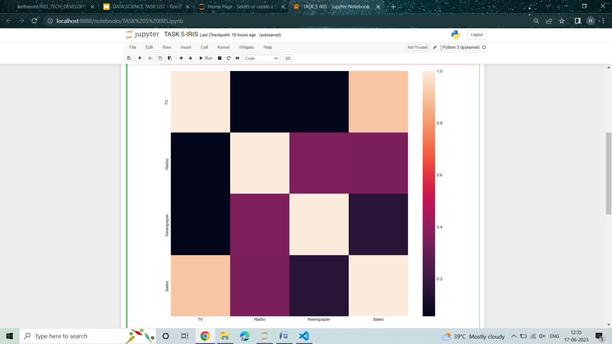

#continue

x = np.array(data.drop(["Sales"], 1))

y = np.array(data["Sales"])

xtrain, xtest, ytrain, ytest = train_test_split(x, y, test_size=0.2, random_state=42)

model = LinearRegression()

model.fit(xtrain, ytrain)

ypred = model.predict(xtest)

data = pd.DataFrame(data={"Predicted Sales": ypred.flatten()})

print(data)

**OUTPUT:**

Predicted Sales

0 17.034772

1 20.409740

2 23.723989

3 9.272785

4 21.682719

5 12.569402

6 21.081195

7 8.690350

8 17.237013

9 16.666575

10 8.923965

11 8.481734

12 18.207512

13 8.067507

14 12.645510

15 14.931628

16 8.128146

17 17.898766

18 11.008806

19 20.478328

20 20.806318

21 12.598833

22 10.905183

23 22.388548

24 9.417961

25 7.925067

26 20.839085

27 13.815209

28 10.770809

29 7.926825

30 15.959474

31 10.634909

32 20.802920

33 10.434342

34 21.578475

35 21.183645

36 12.128218

37 22.809533

38 12.609928

39 6.464413